Sales Data Perform 5 Visualizations
# Read Csv File
import pandas as pd
df = pd.read_csv("Snitch_Fashion_Sales_clean_data.csv")

- Find segment wise orders

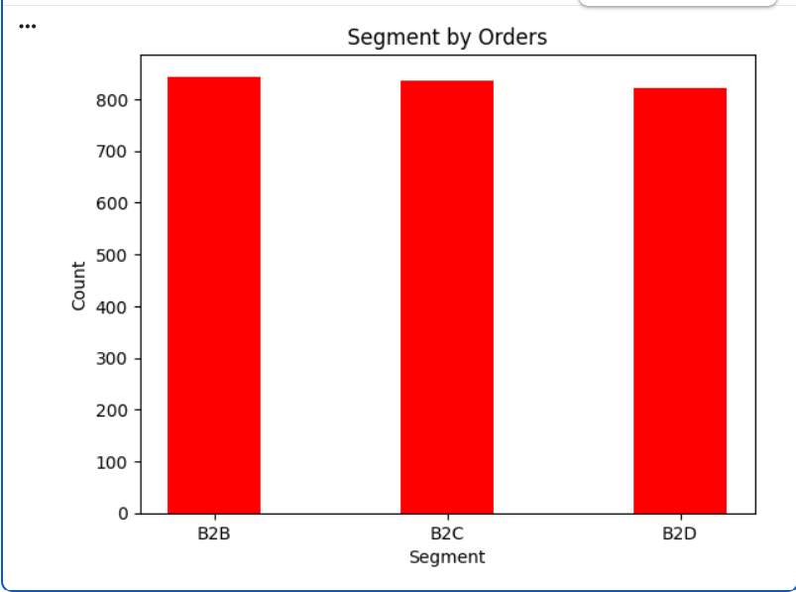
Insights
- B2B segment has the highest number of orders.
- B2C segment is slightly lower than B2B.
- B2D segment has the lowest orders among all segments.
- Order distribution is almost equal across all segments.
- All customer segments contribute consistently to overall business performance.

- Year Wise Profit

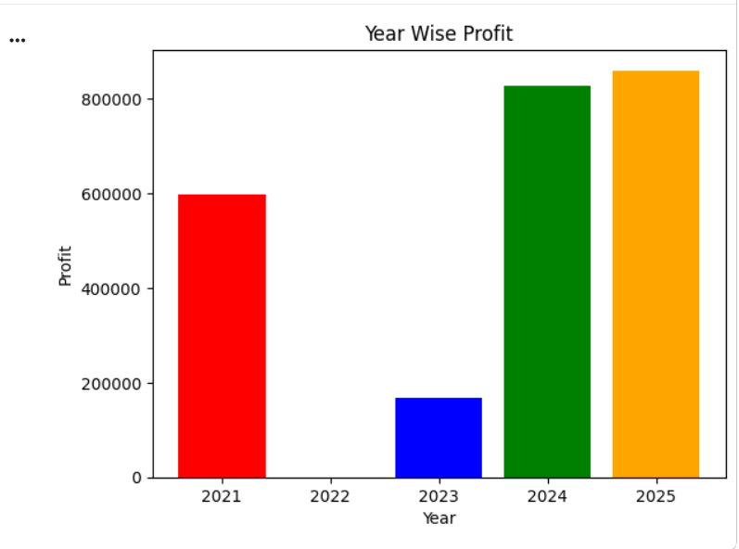

Insights
- 2025 recorded the highest profit, showing the best business performance.
- 2024 also generated very high profit, close to 2025.
- 2021 showed stable profit performance compared to earlier years.
- 2023 had significantly lower profit, indicating weak performance.
- Profit growth increased strongly after 2023, showing business recovery and improvement.

- Sales By City

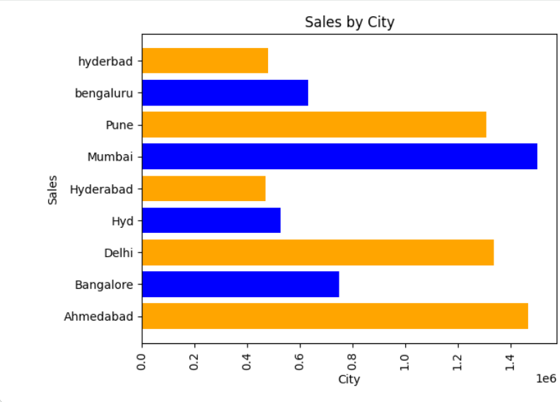

Insights
- Mumbai recorded the highest sales, making it the top-performing city.
- Ahmedabad, Delhi, and Pune also contributed high sales revenue.
- Bangalore and Bengaluru show moderate sales performance.
- Hyderabad-related entries have comparatively lower sales.
- Metro cities contribute the largest share of overall sales growth.

- Product Category Distributions

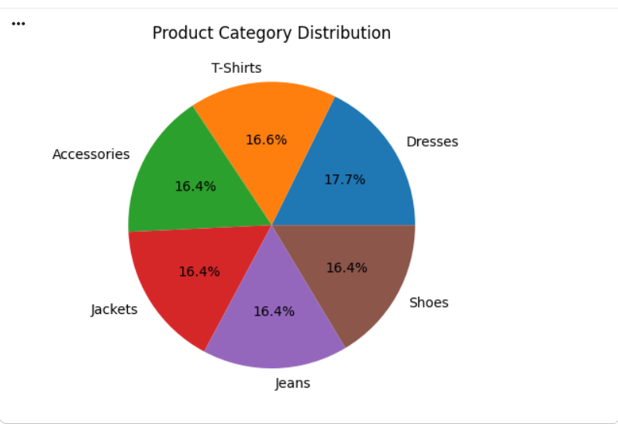

Insights

- Dresses category has the highest share, showing slightly higher customer demand.
- T-Shirts, Shoes, Jeans, Jackets, and Accessories have nearly equal distribution.
- Product demand is balanced across all categories.
- No single category dominates overall sales significantly.
- The business has a diversified product portfolio, reducing dependency on one category.

- Average Discount By Product Category

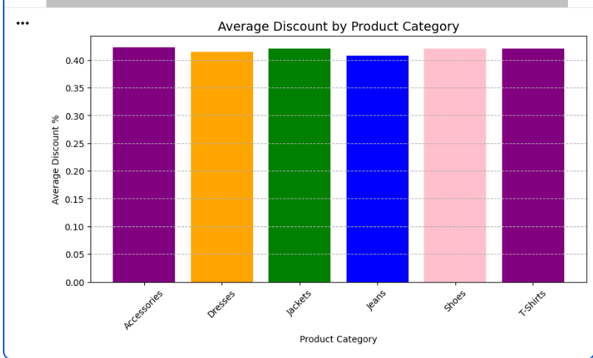

Insights
- Discount percentages are almost equal across all product categories.
- Accessories, Jackets, Shoes, and T-Shirts have slightly higher average discounts.
- Jeans category has the lowest average discount compared to others.
- No major variation is seen in discount strategy across categories.
- The business follows a consistent discount policy for all product categories.

